G
The Gables, The, also Gusty Gables

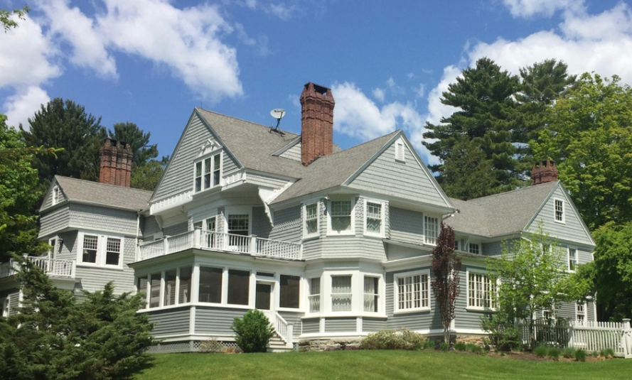

Location: 58 Yokun Avenue, Lenox, Massachusetts.
Date of Construction: 1879.
Architect: Charles F. McKim of McKim, Meade, and White
Architectural Description
The Gables is a two-story, wood-framed house with clapboard and shingle siding, prominently sited atop a small rise. It combines elements of the Shingle Style and Queen Anne architecture, with an asymmetrical façade, irregular footprint, and cross-gabled roof punctuated by multiple dormers. A dentil band encircles the cornice, and four massive brick chimneystacks with multiple flues rise from the roofline. The exterior displays an elaborate variety of shingles: scalloped shingles with incised circles in the front gables; alternating sawtooth and tongue shingles in the right gable; and layered notched shingles over rectangular courses on the second floor. Scroll-sawn brackets support all projecting gables.
The front façade is dominated by two projecting gabled bays. The larger, on the right, features a distinctive trio of attic windows unified by a broken pediment, a motif repeated on the right elevation. Below is a second-floor canted bay window and a one-story sun porch with a balcony above. The left pavilion echoes this composition on a smaller scale, with a single attic window and a French door opening onto a balcony above a later one-story addition that obscures the original front entry. The main entrance was relocated to the north side and is marked by a porch with plain columns and pilasters, spindled balustrade, corner finials, and a door surround with fanlight and sidelights. Rear additions include a substantial two-story extension added in 1885 and a one-story ell. Window types are varied, including original Queen Anne sash with small panes framing larger lights and multi-paned transoms, contributing to the house’s richly textured architectural character.
Interior (2017 Photographs)
Entrance Hall and Stair
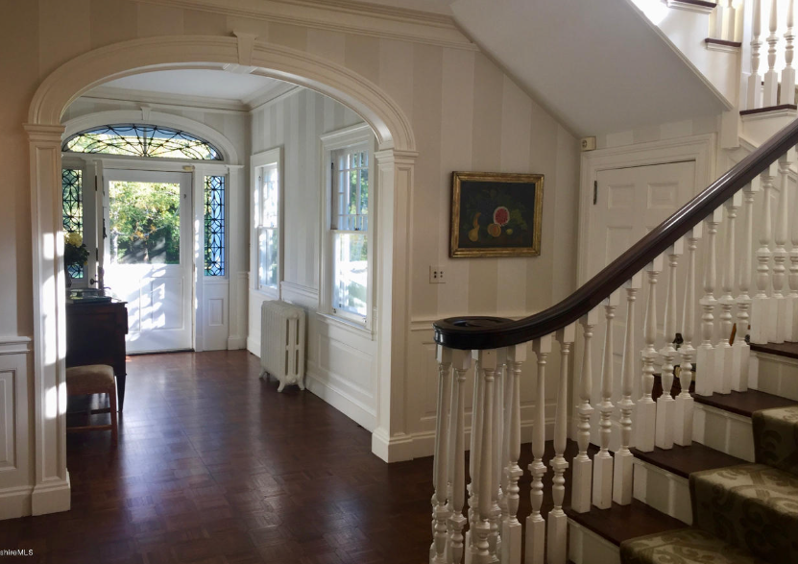
The entrance hall today preserves McKim’s arched opening and principal stair, with white-painted woodwork and dark floors continuing the original spatial hierarchy of arrival and movement.
Staircase
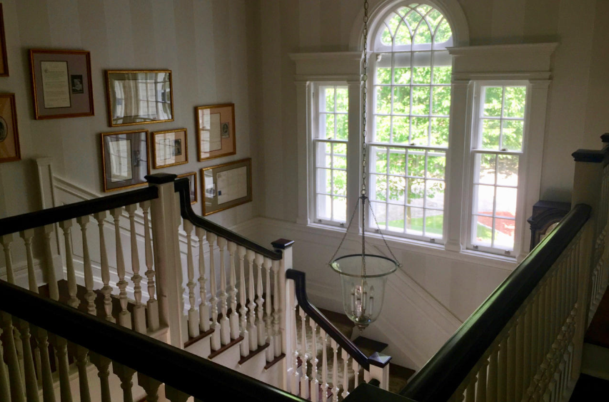

The principal staircase rises in a broad, measured turn, its white balusters and dark handrails framing a tall Palladian-derived window that floods the stairwell with light. The arched central sash and flanking sidelights emphasize verticality and symmetry, making the stair not merely a passage but a carefully composed architectural feature.

Parlor

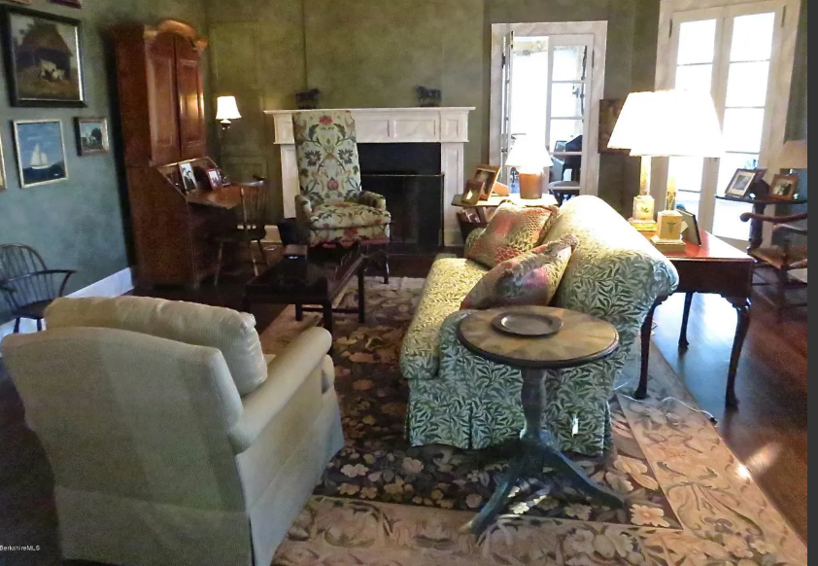

The parlor today is arranged as a comfortable living room centered on the fireplace, with the original mantel and door openings clearly legible beneath later finishes. Current furnishings and textiles emphasize warmth and informality while allowing the room’s proportions and circulation to remain apparent.

Sleeping porch


The sleeping porch remains a light-filled, seasonal room, enclosed by broad bands of windows that open the space to air and views of the surrounding trees. Today it serves as an informal sitting area, preserving the porch’s original character as a place of rest and retreat during the summer months.
Ownership and Social History
Designed by Charles F. McKim and built in 1879 for Miss Mary DePeyster Carey. The DePeysters are also connected to the Lawrences and Remsens. In 1917 the house was sold to Mr. and Mrs. Thomas Strong, and in 1931 it was acquired by Miss Anna Remsen Alexandre, daughter of John Alexandre, builder of Spring Lawn. During her ownership, Miss Alexandre used the house as a center of summer social life in Lenox, entertaining family and friends such as members of the Bayard Hoppin, Buffin, Gould, and Morgan families, as well as figures from the arts including D. W. Griffith and Cornelia Otis Skinner. Luncheon parties for thirty to forty guests were not uncommon. In May 1939 the house was burglarized and ransacked, an incident noted in local accounts. In 1955 Miss Alexandre sold The Gables to Dr. and Mrs. Milos Krofta and moved to a smaller Lenox residence, The Homestead, which she renamed Strawberry House, at 9 Cliffwood Street, Lenox, Massachusetts.

Gardinier (or Gardenier) Family
Origins and Early History
The Gardinier family—sometimes spelled Gardenier, Gardinier, or Gardinierse in early records—is of Dutch colonial origin, established in New Netherland by the mid-seventeenth century. The progenitor was likely Albert Andriessen Bradt van Gardinier (c.1607–1686), a Norwegian-born settler who came to New Amsterdam in 1637 aboard the Rensselaerswyck with his family. His descendants adopted the surname Gardinier, derived from his byname “van Gardinier,” possibly indicating origin from the Dutch town of Garderen in Gelderland, or meaning “the gardener.” The family spread through the Hudson Valley, especially Albany, Kinderhook, and Catskill, and intermarried with the early Dutch families of Van Alen, Van Schaick, and Ten Broeck.
Establishment in the Hudson Valley
By the eighteenth century, the Gardinier name was well established in Kinderhook and Claverack, Columbia County, and later in Kingston, Ulster County. The family prospered as farmers, merchants, and landowners. Many were members of the Dutch Reformed Church, and baptismal records of Albany and Kinderhook contain numerous Gardinier entries from 1680 onward.
Among the earliest recorded members were Dirck Gardinier (1720– ), who owned land in Kinderhook, and his probable son Derick (Dirck) Gardinier (1750– ), who married Elizabeth Van Alen (1758–1854). Their son Barent Gardinier (1776–1822) became the best-known figure of the family’s early American period.
Character and Legacy
The Gardinier family exemplifies the evolution of a Dutch colonial lineage into the civic and political life of the new American republic. Its members combined mercantile pragmatism with a tendency toward eloquence and public service. Though few achieved lasting fame, the family’s connection with the Lawrences, Van Alens, and other early Dutch-American houses places them firmly within the historical fabric of colonial and early national New York.

Gardenier, Barent (1776–1822)
Congressman
Parents: Derick Gardenier (1750– ) and Elizabeth Van Alen (1758–1854).
Married: Sarah (Sally) Lawrence (1775–1854), daughter of David Lawrence (1737–1809) and Sybil Sterry (1742–1831).
Children: Lawrence Gardenier (1795–1891), Anna Eliza Gardenier (1797– ), Laura Gardenier (1799– ), and John Randolph Gardenier (1801– ).
Kinship: Husband of the granddaughter of the great-granduncle of the post–World War II Smith generation.
Early Life and Education
Barent Gardenier was born in Kinderhook, New York, in 1776, the son of Derick Gardenier and Elizabeth Van Alen. He studied law at the Litchfield Law School in Connecticut, the foremost legal academy in the early United States, and was admitted to the bar. In November 1801 he married Sarah Lawrence, daughter of David Lawrence (1737–1809) and Sybil Sterry (1742–1831), thus linking the Gardenier and Lawrence families, both prominent in Hudson Valley and New York political circles.
Legal and Journalistic Career
Gardenier began practicing law in Kingston, Ulster County, where he became known for his eloquence and sharp debating style. He also served as editor and publisher of the New York Courier, a Federalist newspaper that strongly opposed the Jefferson administration.
Congressional Service and Political Controversy
Elected as a Federalist to the Tenth and Eleventh Congresses, Gardenier served as a United States Representative from March 4, 1807, to March 3, 1811. His career in Congress was marked by fierce partisanship and several notable disputes.
He engaged in a celebrated public controversy with Senator John Armstrong of New York concerning Armstrong’s alleged authorship of the “Newburgh letters” of 1783—anonymous circulars that had sought to incite discontent among Continental Army officers over unpaid wages and pensions. Gardenier, a Federalist, used this accusation to undermine Armstrong, a Jeffersonian Republican, in the press and on the floor of Congress.
The Duel with George W. Campbell
In 1808 Gardenier delivered a vehement speech attacking the Jeffersonian Embargo Act, which he viewed as disastrous to American trade. His remarks provoked Congressman George W. Campbell of Tennessee, who replied with personal insults. Gardenier challenged him to a duel, fought on what later became the Bladensburg Dueling Grounds in Maryland. Gardenier was seriously wounded but recovered and was reelected, an event that cemented his reputation as one of the most combative figures in Federalist politics.
Later Career and Death
From 1813 to 1815, Gardenier served as District Attorney for New York’s First District, encompassing New York, Queens, Kings, Suffolk, Richmond, and Westchester Counties. He continued his legal practice in New York City after leaving public office.
Barent Gardenier died in New York City in 1822 and was buried at the First Reformed Church in Kingston. His career reflected the turbulent and highly personal nature of early American politics, in which oratory, print journalism, and even dueling were weapons in the struggle for influence and principle.

Gardenier, Lawrence (1795–1891)
Parents: Barent Gardinier (1776–1822) and Sarah Lawrence (1776–1854).
Married: Catherine (surname unknown).
Children: Randolph Gardinier (1848– ), Edward Gardinier (1849– ), and James Gardinier (1855– ).
Kinship: Third cousin five times removed of the post–World War II Smith generation.
Early Life and Education
Lawrence Gardenier was born in 1795, the eldest child of Congressman Barent Gardenier and Sarah Lawrence, daughter of David Lawrence of Flushing. He was educated in New York and attended Columbia University, where he studied law. His family’s social position and his father’s prominence in politics and journalism gave him entry into the intellectual circles of early nineteenth-century New York.
Legal Career and Association with Aaron Burr
After completing his studies, Gardenier entered the legal profession. By 1825 he had formed a law partnership with Aaron Burr, the former Vice President of the United States. Newspaper accounts of the period noted his brilliance, wit, and polished manners, describing him as one of the most dashing young men in New York society.
In 1827, according to contemporary reports, he was engaged to marry Burr’s only surviving child, Theodosia Burr Alston. Her death at sea when the schooner Patriot disappeared on its voyage from Charleston to New York ended both the engagement and a potential alliance that would have linked Gardenier to one of the most famous families in the early Republic.
Public Reputation and Later Years
Throughout the 1830s and 1840s, Gardenier was known in New York City as a man of letters and fashion. He contributed essays and reviews to periodicals and was regarded by the press as “the Beau Brummell and Chauncey M. Depew of his day.” He was noted for his oratory and often delivered patriotic addresses, including Fourth of July orations from the steps of City Hall during Mayor DeWitt Clinton’s administration. His Life of John Brown (1840) received national notice, although few copies have survived.
Despite his early success, Gardenier’s fortune and reputation declined in old age. Reports from the late 1880s record that “Lawrence Gardinier, once a man of wealth and distinction, was admitted as a poor man to the Home for the Aged in Brooklyn in 1888.” He died there in 1891 and was buried in Trinity Cemetery in Manhattan.
Family Context
His father, Barent Gardenier, was a Federalist congressman noted for his duel with George W. Campbell, a Tennessee representative. Newspapers later confused the two men, claiming that Barent had died of his wounds from the duel, though he in fact lived until 1822.
Lawrence Gardenier’s long life spanned the Federalist era to the Gilded Age, and his career—from promising lawyer and man of fashion to impoverished scholar—illustrates both the brilliance and the instability of New York’s early nineteenth-century elite.

Gilman Family
Background and Intellectual Tradition
The Gilman family traced its American roots to the seventeenth century, with several lines distinguished by academic and clerical achievement. Many early Gilmans were Congregational ministers, scientists, and educators, and their name became associated with the intellectual life of New England.
Gilman–Lawrence Connections
The connection between the Gilman and Lawrence families began with the marriage of Arthur Coit Gilman (1855–1890) and Bessie Amelia Lawrence (1858–1937). Bessie was the daughter of Effingham Lawrence (1820–1878), owner of Magnolia Plantation in Louisiana and a member of the extensive Lawrence family of Flushing, New York. Through this union, the scholarly New England Gilmans—descendants of Puritan ministers and educators—were linked with the Lawrences, a family distinguished for its wealth, public service, and artistic patronage. The match symbolized the merging of intellectual and mercantile traditions: the Gilmans representing the academic and reformist energies of New England, the Lawrences the civic and commercial vigor of New York. This alliance introduced the Gilmans to a wider cultural and social milieu, and their descendants carried forward the combined legacies of both families in education, the arts, and public life.
Residences and Connections to Snedens Landing
A branch of the Gilman family resided near Snedens Landing, New York, where many Lawrences had year-round or summer homes. Winthrop S. Gilman Jr. (1839–1923), a cousin of the Baltimore and New York Gilmans, built Niederhurst, a Gothic Revival mansion overlooking the Hudson River. Gilman, a banker and amateur architect, became the first local historian of Snedens Landing and financed several of its early public buildings, including a church and schoolhouse. The area’s later artistic and intellectual residents, including Eric and Anne Gugler, thus lived in proximity to properties once owned by the extended Gilman family.
Summary
From colonial ministers and educators to financiers and critics, the Gilmans exemplified a blend of intellect, reform, and artistic taste. Through marriage, they were connected to the Lawrence family and, through the Snedens Landing branch, to the Hudson River’s cultural landscape. The family’s legacy endures in American academic and cultural institutions—from the Gilman School in Baltimore to the academic traditions shaped by Daniel Coit Gilman at Johns Hopkins University.

Gilman, Arthur Coit (1855–1890)
Parents: Rev. Edward Whiting Gilman (1823–1900) and Julia Silliman (1826–1892).
Married: Bessie Amelia Lawrence (1858-1937).
Children: Arthur Lawrence Gilman (1878–1939), Edward Coit Gilman (1879–1909), and Joseph Lawrence Gilman (1881–1882).
Kinship: Husband of the first cousin four times removed of the post–World War II Smith generation.
Early Life and Marriage
Arthur Coit Gilman was born in 1855, the son of Rev. Edward Whiting Gilman, a New England clergyman, and Julia Silliman, daughter of Benjamin Silliman Jr., the noted Yale chemist and geologist. Arthur Coit was the nephew of Daniel Coit Gilman, the first president of Johns Hopkins University, founding president of the Carnegie Institution, and co-founder mof the Gilman School, Baltimore.
Arthur married Bessie Lawrence in 1878 at Magnolia Plantation in Louisiana, connecting him to the Lawrence family of Flushing and New York. The couple lived in comfort and social prominence, maintaining a residence in Flushing and summering in fashionable circles.
Career
Gilman began his professional life modestly as an office boy at the tea firm L. H. Labaree & Co. in March 1879 at a salary of eight dollars a week. Through apparent diligence and ability he rose rapidly and eventually became a partner, though without ever investing capital. His financial standing and refined tastes placed him among the well-to-do of the late Gilded Age.
He and his wife were active in New York society and were among the earliest box holders at the Metropolitan Opera, where Arthur was noted as an ardent admirer and defender of Richard Wagner’s music—a passion that was fashionable among the city’s cultivated elite of the 1880s.
Death and Scandal
On December 15, 1890, Arthur told his wife that he was unwell and would remain home from work. He sent a telegram to the firm excusing his absence and promised to join his wife and her sister for lunch at Delmonico’s if he felt better. Later that morning, when his employer, Mr. Labaree, came to Flushing to discuss business, the servant found Gilman’s bedroom door locked. It was forced open, and Arthur was found dead on his bed, partly clothed. The attending physician declared the cause of death to be heart failure.
Several months later, auditors discovered that Gilman had embezzled approximately $220,000 (equivalent to about $5 million in modern value) from the firm between 1884 and 1890. The investigation concluded that the thefts had been “continuous, deliberate, and intentional, extending over six years and conducted with a degree of skill and baseness of treachery which can find but few cases to parallel.” The money’s destination was never traced; his personal income appeared adequate for his lifestyle, and no hidden assets were located.
In the firm’s safe were found life-insurance policies totaling $56,000, payable to Bessie Gilman. The company asserted that the stolen funds had been used to pay the premiums and laid claim to the policies. The dispute went to court, where Mrs. Gilman maintained that the firm was entitled only to the value of the premiums, not to the benefits themselves. These policies were the only assets remaining to her.
Although the physician’s report stated “heart failure,” the timing of Gilman’s death, the revelation of the embezzlement, and the existence of the insurance policies led to widespread suspicions of suicide, but by the time the fraud was uncovered it was too late for an autopsy.
The Supreme Cort of New York ruled:
“Held, that the plaintiff was entitled to recover the amount of such premiums as were paid from firm moneys by Gilman in fraud of the rights of the firm, but that he was not entitled to recover the moneys realized from the policies themselves.
That the partnership relation forbade the idea that one partner could steal or embezzle from the firm, inasmuch as each partner had an undivided part of the whole, and not the whole of an undivided part of the firm property.
That, as the wife had an insurable interest, protected by the laws of the State, the policy and its proceeds were not solely the result of Gilman’s payment of the premiums. (Per O’Brien, J.)
That, therefore, assuming the partnership relation to be one of trust, equity would not follow a fund diverted, but which had been subsequently invested so as to unite it with other property interests or rights, and give the whole investment to the party whose money had been diverted. (Per O’Brien, J.)”
Character and Legacy
Arthur Coit Gilman’s life combined social brilliance, financial promise, and tragic collapse. His downfall, one of the most striking private scandals of late nineteenth-century New York commerce, destroyed a respected firm and left his family in near ruin. His story, though little remembered, reflects the speculative fever and moral fragility of the Gilded Age—an era when ambition, appearances, and temptation often proved fatally intertwined.

Gilman, Elizabeth Lawrence (1905–2006)
Parents: Arthur Lawrence Gilman (1878–1939) and Elizabeth Wright Walter (1875–1964).
Married: Malcolm Evelyn Anderson (1900–1950).
Children: None recorded.
Kinship: Third cousin twice removed of the post–World War II Smith generation.
Early Life and Education
Elizabeth Lawrence Gilman was born in 1905 into a family prominent in both New York society and the literary world. Her father, Arthur Lawrence Gilman, was descended from the Lawrence family of Flushing, and her mother, Elizabeth Wright Walter, came from a New England family of professional and academic distinction. She attended Smith College, graduating in 1927.
Marriage and Career
In 1936 she married Malcolm Evelyn Anderson, a Princeton graduate and member of the editorial staff of The New Yorker. The marriage ended in divorce in 1940. Elizabeth worked for a time in the publishing world and later at F. A. O. Schwarz in New York City. She was known for her intelligence, humor, and participation in the city’s artistic and intellectual life.
Civic and Cultural Interests
In later years she devoted herself to environmental and community causes, dividing her time between New York and the Adirondacks. She was active in the National Audubon Society, the Adirondack Mountain Club, the Society for the Preservation of the Adirondacks, the Saranac Lake Free Library, and the Saranac Lake Village Improvement Society. She was also a member of The Bohemians, a New York musicians’ club with a long and distinguished history.
Later Years and Death
Elizabeth Gilman spent her final years in Kennett Square, Pennsylvania. She died in 2006 at the age of 101, remembered for her commitment to conservation and the arts, and for a life that bridged the refined world of her Lawrence ancestors and the civic-minded modernism of the twentieth century.

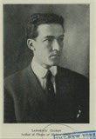
Gilman, (Arthur) Lawrence (1878–1939)

Parents: Arthur Coit Gilman (1855–1890) and Bessie Amelia Lawrence (1858–1937).
Married: Elizabeth Wright Walter (1874–1964).
Children: Elizabeth Lawrence Gilman (1905–2006).
Kinship: Second cousin three times removed of the post–World War II Smith generation.
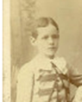
Early Life and Education
Arthur Lawrence Gilman, who always published under the name Lawrence Gilman, was born in 1878. He studied art at the Collins Street Classical School in Hartford, Connecticut, under the painter William M. Chase, and taught himself music in both theory and practice, mastering the organ and piano. His parents were devoted Wagnerians, and the household’s musical standards were high; this early exposure shaped his lifelong musical convictions and uncompromising tastes.
Career as Critic and Writer
Gilman was one of the most influential and stylistically distinctive American music critics of the early twentieth century. He began as a journalist for the New York Herald from 1896 to 1898, later joining Harper’s Weekly (1901–1913), where he advanced to managing editor. From 1915 to 1923 he wrote for the North American Review, and from 1925 onward for the New York Herald Tribune. He also annotated concert programs for the New York Philharmonic-Symphony Orchestra and the Philadelphia Orchestra and served as the radio commentator for Philharmonic broadcasts. His lucid, often poetic commentaries became part of the tradition of American musical criticism and are still occasionally quoted in modern program notes.
Gilman’s published books included Phases of Modern Music (1904), The Music of Tomorrow (1906), Stories of Symphonic Music (1907), A Guide to Strauss’s “Salome” (1907), A Guide to Debussy’s “Pelléas et Mélisande” (1907), Edward MacDowell: A Study (1909), Aspects of Modern Opera (1908), Nature in Music (1914), A Christmas Meditation (1916), Music and the Cultivated Man (1929), Wagner’s Operas (1937), and Toscanini and Great Music (1938). He also composed several musical works, including “A Dream of Death” (1903), “The Heart of a Woman” (1903), and “The Curlew” (1904).
Critical Style and Opinions
Lawrence Gilman’s prose was elegant, precise, and often merciless. One contemporary described him as “a suave, sensitive, and rather morose individual of extremely aesthetic appearance who wore a fur-collared overcoat, worked for hours over each carefully turned paragraph, and produced a type of elegantly tortured prose that many New York concertgoers regarded as literature.” He was said to wear cotton in his ears at all times except during concerts, which he attended with ritual solemnity—removing his earplugs only to listen.
A devoted Wagnerian, Gilman believed that operatic progress had ended with Wagner: “Since that day when, a quarter of a century ago, Richard Wagner ceased to be a dynamic figure in the life of the world, the history of operatic art has been, save for a few conspicuous exceptions, a barren and unprofitable page.” He had little patience for the bel canto revival: “The melodic style of the Young Italian opera-makers…gives the singers opportunity to pour out their voices in that lavish volume and intensity which provoke applause as infallibly as horseradish provokes tears.”
He loathed the new atonality of Webern, whose Five Pieces he described as “scarcely perceptible tonal wraiths, mere wisps and shreds of sound, fugitive astral vapors…though once or twice there are briefly vehement outbursts, as of a gnat enraged.” Stravinsky fared no better: “The History of a Soldier is tenth-rate Stravinsky… probably the nearest that any composer of consequence has ever come to achieving almost complete infantilism.”
Gershwin, in Gilman’s view, was unworthy of serious consideration. Of Porgy and Bess he wrote: “Listening to such sure-fire rubbish as the duet between Porgy and Bess, ‘You is my woman now,’ you wonder how the composer could stoop to such easy and needless conquests.” Of Rhapsody in Blue he said, “How trite and feeble and conventional the tunes are; how sentimental and vapid the harmonic treatment, under its guise of fussy and futile counterpoint.”
Massenet he dismissed with unmatched venom: “This intrepid composer, gifted with the spiritual distinction of a butler, the compassionate understanding of a telephone girl, and the expressive capacity of an amorous tomtit, had the courage to choose as a subject for music the greatest of all tragi-comedies… and with it he did his worst.”
He found Puccini’s Madame Butterfly nearly comic: “It would scarcely seem to require elaborate argument to demonstrate that the presence in a highly emotional lyric-drama of a gentleman named Benjamin Franklin Pinkerton—a gentleman who is, moreover, the hero of the piece—is, to put it briefly, a little inharmonious.”
Controversy and Retaliation
Gilman’s own invective often provoked retaliation. After he repeated a popular but false story that a Church Council had once debated whether women had souls, the Jesuit magazine America responded with gleeful ferocity, asking, “But who is Mr. Lawrence Gilman?” It described him as “a gentleman with a weakness for music, a young-eyed cherub, fond of harmony… said to play prettily upon the organ and piano.” It mocked his mingling of music and metaphysics and concluded that his credulous repetition of the legend showed “a trusting gentle nature… devoid of the critical spirit; his head is in the clouds.”
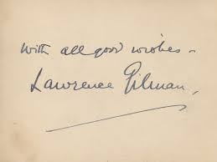
Death and Legacy
Lawrence Gilman died on September 8, 1939, at Sugar Hill in Grafton, New Hampshire. On October 22, 1939, the New York Philharmonic broadcast a memorial concert in his honor, featuring Siegfried’s Funeral March and the closing scene of Götterdämmerung.

Brilliant, exacting, and frequently caustic, Lawrence Gilman embodied the era of the literary music critic—when the sharpness of one’s pen could still shape reputations and musical taste.

Golden Era (San Francisco, 1852–1894)

The Masthead
Founding and Purpose
The Golden Era was founded in 1852 by Rollin M. Daggett and J. McDonough Ford in San Francisco. It was conceived as a “Good Family Newspaper,” intended for “every parlor and miners’ cabin,” appealing alike to merchants, farmers, and mechanics. Its editors declared it would be “untainted with politics and unbiased by religious prejudice.” The paper reflected the varied life of Gold Rush California, publishing recipes, ship news, serialized fiction, social notices, and brief reports of violent or comic events.
Editorial Character
From its earliest years, The Golden Era promoted a distinctly Western literary voice, calling for a national literature “racy of the soil.” It argued that foreign writers should not dominate the reading public and urged the encouragement of native authors who could capture the life and color of the Pacific frontier. Its rural readers, scattered across mining camps and small towns, looked forward to each issue as a link to civilization and amusement.
Joseph Effingham Lawrence’s Editorship
Joseph Effingham Lawrence (1825–1878) joined the paper in 1854 and in 1860 became its editor and co-owner. Under his leadership The Golden Era entered its most influential period. Lawrence shifted the paper away from crude local color toward more polished satire, serialized fiction, and literary criticism. He combined what contemporaries called “European intellectualism and Pacific Coast empiricism,” helping to create what later scholars described as “one of history’s most exciting intellectual atmospheres.” Lawrence’s genial personality and taste made him a beloved figure among young writers; one observer recalled “amiable Joe Lawrence, an inveterate pipe-smoker, a pillar of cloud as he sat in his editorial chair, an air of literary mystery enveloping him.”
Notable Contributors
Lawrence had an instinct for discovering new talent. He was the first editor to publish the young Samuel Clemens, later known as Mark Twain, who arrived in San Francisco in 1864. Lawrence paid Twain five dollars an article and encouraged the irreverent humor that became his signature. Twain’s parodic descriptions of women’s fashions and his lampoons of Spiritualist séances appeared first in The Golden Era.
Bret Harte also began his career there. Hired initially as a compositor, he soon attracted Lawrence’s attention and was invited to write. Between 1857 and 1865 Harte published eleven poems and seventy-four sketches and articles in The Golden Era. His unfinished serial M’liss appeared there before he moved to The Californian and later to national prominence.
Artemus Ward and the Humor of the West
Lawrence’s friendship with Edward Hingston, advance agent for the humorist Artemus Ward (Charles Ferrar Brown), introduced The Golden Era to the popular comic style that bridged the American frontier and the English music hall. Hingston recalled Lawrence’s “magnanimous” enthusiasm, declaring that he would make an entire issue an “Artemus Ward number.” This episode reflected Lawrence’s easy wit and his skepticism toward the Spiritualism then fashionable among his sisters Hannah and Lydia Lawrence, both active mediums.
Cultural Milieu
The world of The Golden Era was that described later by Twain in Roughing It: overwhelmingly male, young, and irreverent, a mixture of violence and idealism that gave American humor its sharpness. The paper’s advertisements and verse reflected the crude abundance of the time—flea powders and patent pianofortes, codfish and Sarsaparilla tonics—mingling with theater notices and mock poetry contests.
Later Years and Legacy
After Lawrence’s death the paper declined, eventually ceasing publication in the 1890s. Yet its influence was lasting. It had fostered the first true Western literary culture and served as the crucible for the two writers—Twain and Harte—who would carry California’s voice to the wider world.
Name and Identification
Although later family and biographical sources refer to the editor as Joseph Effingham Lawrence, the middle name Effingham was never used in California. In all contemporary San Francisco newspapers, advertisements, and legal records he appears simply as Joseph E. Lawrence or J. E. Lawrence, and was familiarly known as “Joe Lawrence.” Effingham was, however, his baptismal name, bestowed in honor of the long-standing imaginary Lawrence and Townley family tradition of that name. See Effingham.

Gilbert Lawrence House

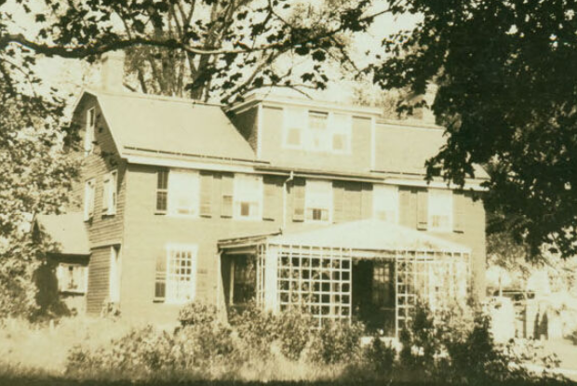

Location: near northwest corner of Lawrence Neck Road (3rd Avenue) and 21st Street, Flushing, Queens, New York.
Gilbert Lawrence (1776-1870) is the third cousin six times removed on the post-World War II Smith generation.
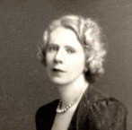
Gorges, Marjorie Howard (1894–1948)

Parents: Capt. Edward Howard Gorges (1868– ) and Margaret Malone (1862– ), both of Ireland.
Married: (1) James Lawrence Breese II (1884–1959); (2) John Duncan Pearmain (1896–1971) in 1942.
Children: With James Lawrence Breeze: Frances Potter Breese (1916–1997), Mary N. C. Breese (1919–1999), Anne Breese (1922–2019), and James Lawrence Breese (1927–2009).
Kinship: Wife of the sixth cousin three times removed of the post–World War II Smith generation.
Early Life
Marjorie Howard Gorges was born in Montreal, Quebec, in 1894, the daughter of Captain Edward Howard Gorges, a British Army officer of Irish descent, and Margaret Malone of County Cork. The Gorges family had long-standing Anglo-Irish and military connections; several members had served in the British armed forces in both Ireland and Canada. Marjorie’s early years were spent in Montreal, where her family belonged to the English-speaking professional and military class that maintained close cultural ties with both London and Dublin.
Marriage to James Lawrence Breese
In 1915 she married James Lawrence Breese (1887–1958), an engineer, inventor, and photographer, and a member of the socially prominent Breese family of New York. After their marriage, the couple moved from the East Coast to Santa Fe, New Mexico, where they became part of the city’s small but influential community of artists, architects, and intellectuals.
Marjorie and James had four children—Frances, Mary, Anne, and James Jr.—and their home became a gathering place for the region’s emerging cultural scene during the interwar years. Their marriage, however, was troubled, and they eventually divorced.
Later Life and Second Marriage
In 1942 Marjorie married John Duncan Pearmain in Albuquerque, New Mexico. Pearmain, a British-born mechanical engineer and industrial designer, had settled in the American Southwest after working in Los Angeles and New York. During the 1940s, Marjorie was active in civic and pacifist organizations, notably the Women’s Committee for a Lasting Peace, which advocated international cooperation and reconstruction in the aftermath of World War II.
Illness and Death
In the years following the war, Marjorie suffered from declining health, including what was described at the time as “nervous exhaustion.” On January 24, 1948, she was found dead by her twenty-one-year-old son, James Jr., hanging in a closet of her Albuquerque home. The District Attorney made a preliminary determination of suicide, but an official inquest was held due to questions surrounding the circumstances. Contemporary newspaper reports confirmed the verdict as death by self-inflicted hanging.
Legacy
Marjorie’s life reflected the displacement and cultural crossing of her generation—an Irish-born Canadian woman who married into New York society and helped foster the early artistic milieu of Santa Fe before succumbing to personal tragedy. Her children continued the family’s cultural legacy: Frances became involved in the arts, Mary and Anne were associated with educational and civic work in New Mexico, and James Jr. pursued a career in engineering.
Marjorie Gorges Breese Pearmain remains a poignant figure in the Breese family’s southwestern chapter—her cosmopolitan background and tragic end emblematic of both the promise and the fragility of her era.

Gugler, Eric (1889–1974)
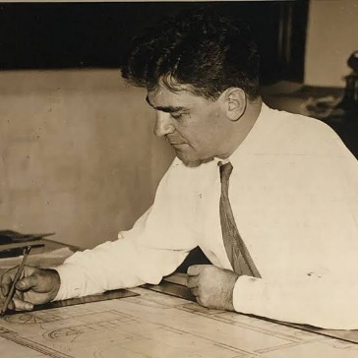

Parents: Julius Gugler (1848–1919) and Bertha Rose Bremer (1854–1901).
Married: Anne Elizabeth Tonetti (1903–1990).
Children: None recorded
Kinship: Husband of Anne Tonetti, the fourth cousin twice removed of the post–World War II Smith generation.

Early Life and Family Background
Eric Gugler was born in Milwaukee, Wisconsin, in 1889, into a family distinguished in printing and the arts. His grandfather, Henry Gugler Sr. (1816–1880), was a German-born engraver for the U.S. Bureau of Engraving and Printing during the Civil War, noted for his life-sized engraving of Abraham Lincoln. Later, Henry and his son Julius founded H. Gugler & Son Lithographing Company in Milwaukee. Julius Gugler was both a printer and a poet, and his daughter Frida Gugler (1874–1966) became a painter who studied with William Merritt Chase. Eric inherited this blend of technical skill and artistic sensibility.
Education and Early Career
Gugler studied at the Armour Institute (now Illinois Institute of Technology) and at the School of the Art Institute of Chicago. He earned his B.A. from Columbia University in 1911 and studied for three years at the American Academy in Rome. While in Rome, he designed a monumental plan for a new approach to St. Peter’s Basilica—a tree-lined boulevard of reflecting pools leading from Bernini’s piazza to the Tiber. His classical training and sense of proportion remained central to his later work.
World War I and Camouflage Design
From October 1917 to December 1918, Gugler served in the U.S. military, designing camouflage for ships to protect them from submarine attack. His work included experimental structural alterations to funnels and masts to distort enemy rangefinding. These innovations placed him at the intersection of engineering and art, and he was later cited in Camoupedia as a pioneer in applied camouflage design.
Architectural Career in New York
After the war, Gugler opened an office in New York City at 101 Park Avenue, sharing space with McKim, Mead & White. In 1929 he won first prize for the design of a Chicago War Memorial, a vast, unbuilt monument on an island at the end of Congress Street. His career flourished in the 1920s and 1930s, combining classical discipline with a modern monumental sensibility.
Marriage to Anne Tonetti
Gugler rented a house across from sculptor Mary Lawrence Tonetti’s home and studio on West 40th Street. There he met Mary’s daughter, Anne Elizabeth Tonetti, whom he married in 1932. Their wedding, witnessed by Justice Benjamin Cardozo, united two families active in New York’s artistic world.
Forum Auditorium, Harrisburg
In the early Depression years, Gugler and his associate Richard Brooks designed the interior of the Forum Auditorium in the Pennsylvania State Education Building, Harrisburg. They conceived the ceiling as a celestial map, painted on canvas panels with gold constellations, silver planetary orbits, and more than a thousand stars—365 of them crystal. The architects described their intent as a tribute to the grandeur of the heavens and the patient curiosity of humankind. At the center was a great silver sunburst concealing the auditorium’s ventilator, incorporating symbolic diagrams of the major theories of the solar system. The building remains a celebrated work of Art Deco and astronomical imagination.
White House and the West Wing
In 1933 Franklin D. Roosevelt commissioned Gugler to rebuild the West Wing of the White House. Roosevelt wanted easier access from his living quarters and an office that would subtly accommodate his physical limitations. Gugler excavated a full basement, added subterranean offices under the lawn, and extended the building eastward to create a new Cabinet Room and Oval Office.
The new Oval Office, completed in 1934, was an elegant blend of Georgian and Art Moderne styles, with bookcases set in niches, cove lighting hidden in the cornice, and a ceiling medallion bearing the Presidential Seal. The twin armchairs before the fireplace—one for the president and one for guests—were arranged so that Roosevelt could meet others at eye level while seated. The design remains in place to this day.
Other Architectural and Preservation Work
Gugler designed the White House’s 1938 Steinway piano, decorated with gilt figures of American folk musicians and dancers by Denbar Beck, with sculptural eagles by Albert Stewart. He also supervised the restoration of the Sub-Treasury Building on Wall Street, later Federal Hall, and worked with civic leaders to save Castle Clinton from demolition. His advocacy, supported by Eleanor Roosevelt and Felix Frankfurter, helped persuade President Truman to establish Castle Clinton National Monument in 1946.
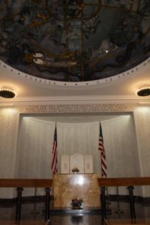
Collaborations and Memorials
Gugler’s long collaboration with sculptor Paul Manship began in the 1920s and produced several major works. They designed the Hutchins Memorial Bench in Central Park (1932), featuring carvings by the Piccirilli Brothers and a sundial by Albert Stewart. Together they also created the Theodore Roosevelt Memorial on Roosevelt Island (1963–1967), a vast granite plaza encircled by inscriptions and a 17-foot bronze statue by Manship.
His work extended to memorials across the country: the Mayo Memorial Amphitheater, the Harvey Firestone Memorial in Akron, and the American Military Cemetery at Anzio, Italy. The ceiling of the Anzio chapel (right) reprises his celestial motif, with zodiacal constellations and planets placed in their positions on January 22, 1944, the day of the Allied landing.
Val-Kill and Arthurdale
Gugler worked closely with Eleanor Roosevelt on her Hyde Park cottage, Val-Kill, and later on the Arthurdale subsistence-homesteading project in West Virginia. Although the project became mired in bureaucratic inefficiency and overspending, Gugler’s redesigns of the prefabricated cottages were structurally sound and humane in scale.
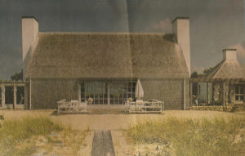
Later Projects
Gugler’s later works include Chip Chop, the beach house of actress Katharine Cornell on Martha’s Vineyard, completed in 1957, and the Armillary Sphere for the 1964 New York World’s Fair, again with Paul Manship. He also proposed an immense open-air temple, “The Hall of Our History,” for Warm Springs, Georgia, an unrealized project intended to house the nation’s founding documents.
Eleanor Roosevelt and Helen Keller at Chip Chop

Retirement and Death
Eric and Anne Gugler retired to The Green Barn at Snedens Landing, New York, long associated with the Tonetti family and their artistic circle. Gugler died there on May 16, 1974. Anne survived him until 1990.
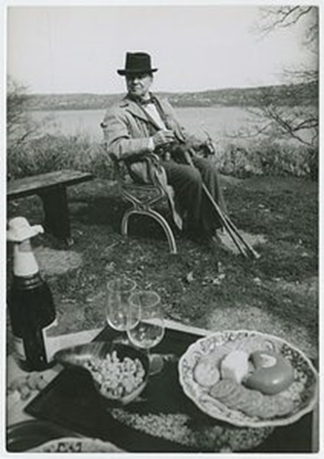
Eric Gugler in retirement (left)
Green Barn (below)
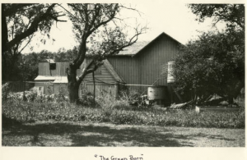

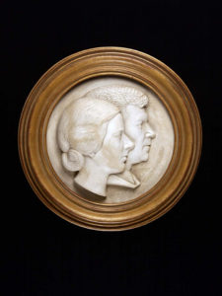
Legacy
Eric Gugler’s work spanned architecture, art, and civic design. From ship camouflage to celestial ceilings, from the Oval Office to national memorials, he combined technical discipline with imaginative symbolism. His lifelong fascination with the harmony of the cosmos shaped spaces that sought to reconcile human order with the vastness of creation.
Anne and Eric Gugler by Paul Manship

11`

